Task 1
Create One VPC with One Public Subnet and One Private Subnet
Objective
Objective
Create a custom VPC with:
- 1 VPC
- 1 Public Subnet
- 1 Private Subnet
- 1 Internet Gateway
- 1 Public Route Table
- 1 Private Route Table

Architecture
Internet
|
Internet Gateway
|
-------------------
| |
Public Route Table Private Route Table
| |
Public Subnet Private Subnet
10.0.1.0/24 10.0.2.0/24
|
Public EC2 (Optional)

Step 1: Login to AWS Console
- Sign in to the AWS Management Console.
- Search for VPC in the search bar.
- Open the VPC service.

Step 2: Create the VPC
- In the left menu, click Your VPCs.
- Click Create VPC.
Fill in the details:
Field | Value
Resources to create | VPC only
Name tag | Advanced-VPC
IPv4 CIDR | 10.0.0.0/16
IPv6 CIDR | No IPv6 CIDR Block
Tenancy | Default
Click Create VPC.
Expected Result: A new VPC named Advanced-VPC is created.
📸 Screenshot 1: VPC details page.
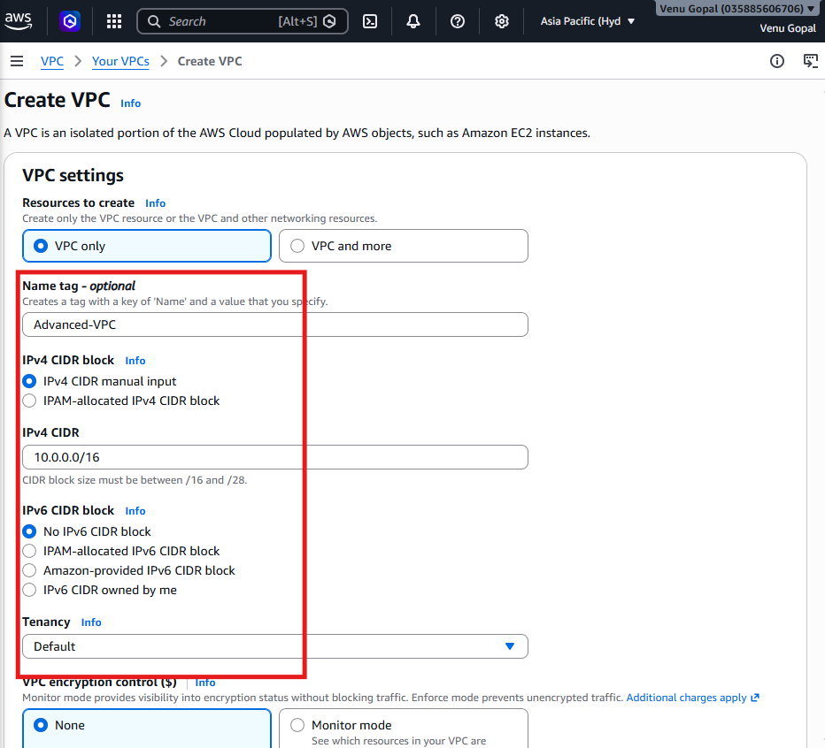
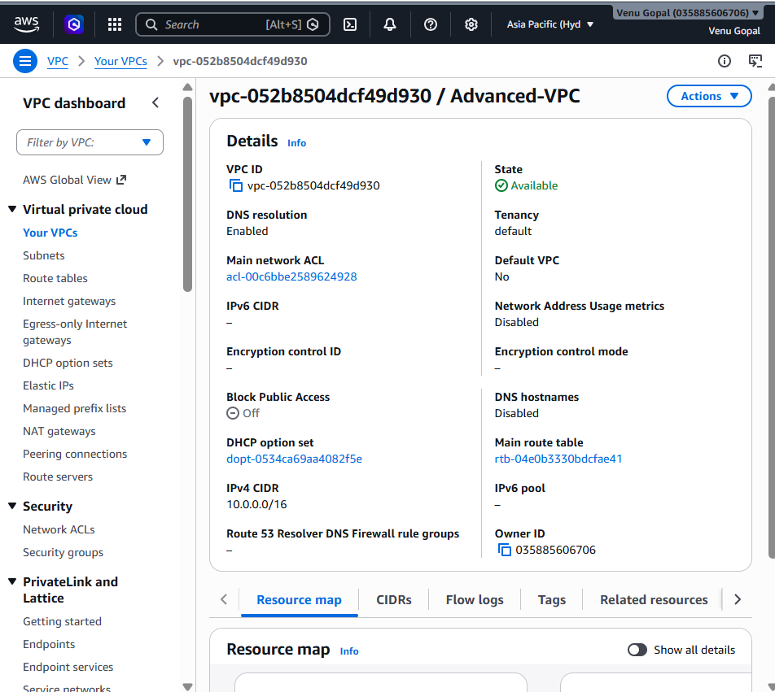

Step 3: Enable DNS Hostnames (Recommended)
- Select Advanced-VPC.
- Click Actions → Edit VPC Settings.
- Enable:
  - ✅ Enable DNS Resolution
  - ✅ Enable DNS Hostnames
- Click Save.
Why?
DNS hostnames allow EC2 instances with public IPs to receive public DNS names.
📸 Screenshot 2: DNS settings enabled.
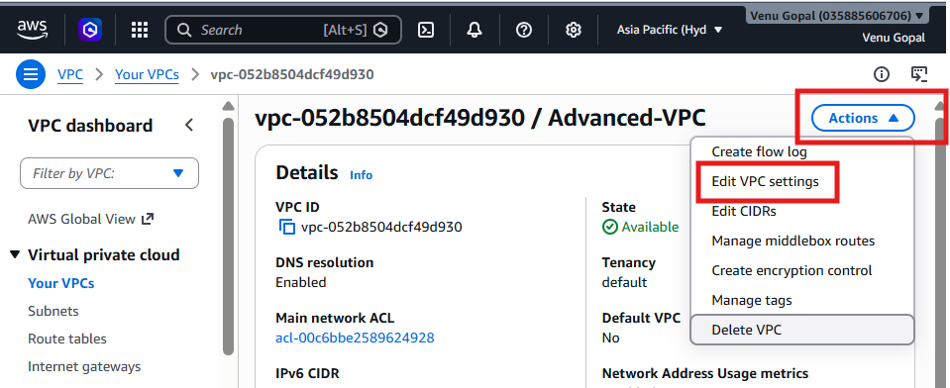
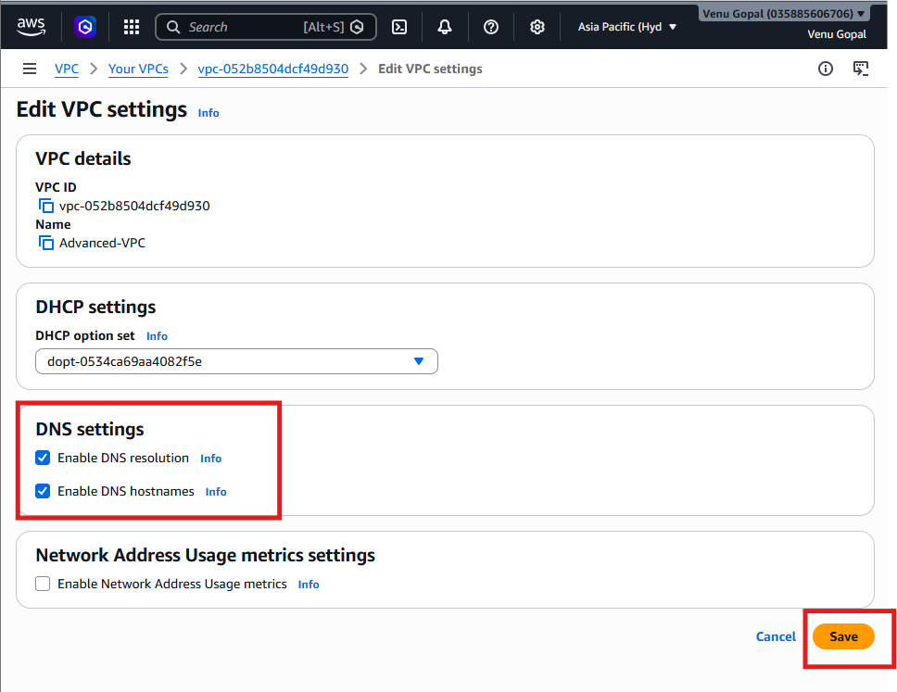

Step 4: Create the Public Subnet
- In the left menu, click Subnets.
- Click Create Subnet.
Enter:
Field | Value
VPC | Advanced-VPC
Subnet Name | Public-Subnet
Availability Zone | us-east-1a (or any available AZ)
IPv4 CIDR | 10.0.1.0/24
Click Create Subnet.
📸 Screenshot 3: Public subnet created.
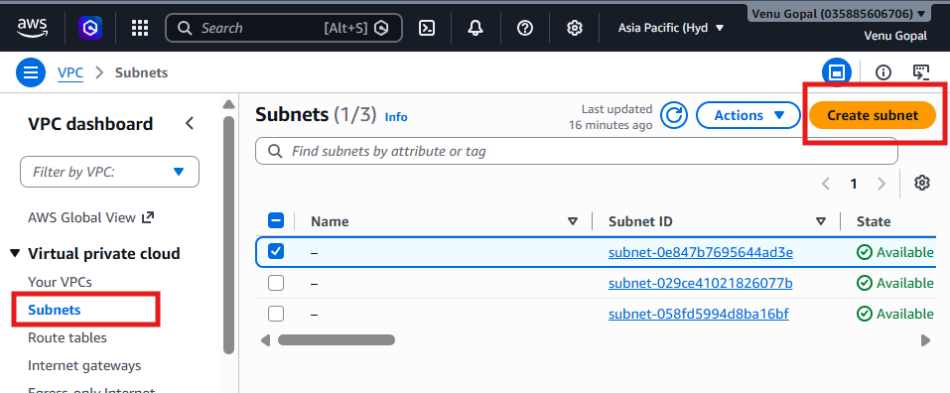
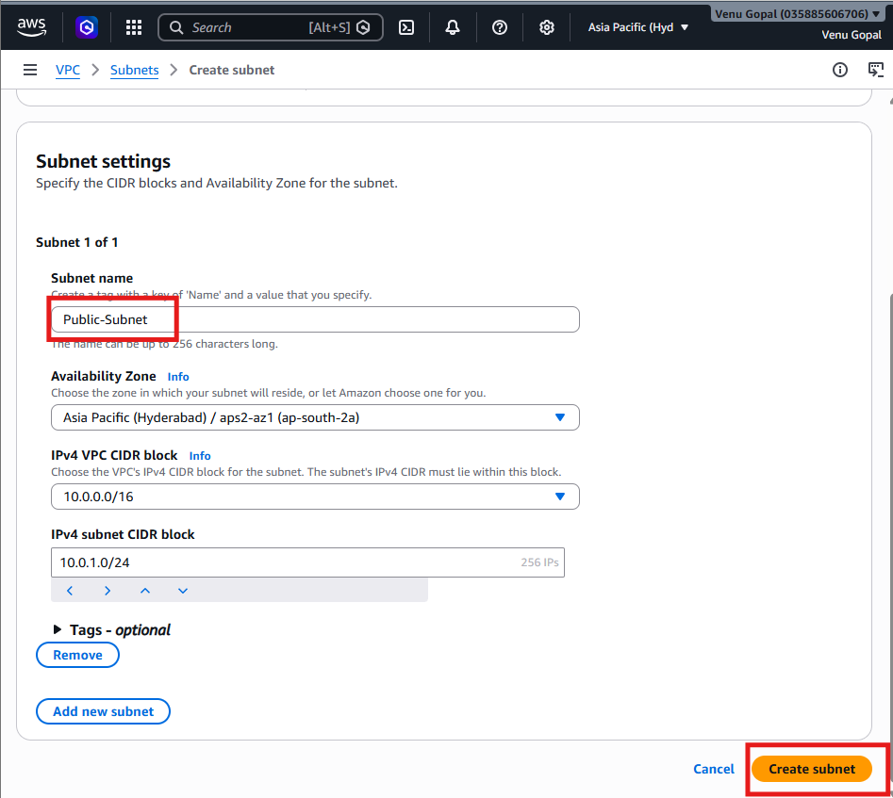
Step 5: Create the Private Subnet
Again, click Create Subnet.
Enter:
Field | Value
VPC | Advanced-VPC
Subnet Name | Private-Subnet
Availability Zone | us-east-1b (or another available AZ)
IPv4 CIDR | 10.0.2.0/24
Click Create Subnet.
📸 Screenshot 4: Private subnet created.
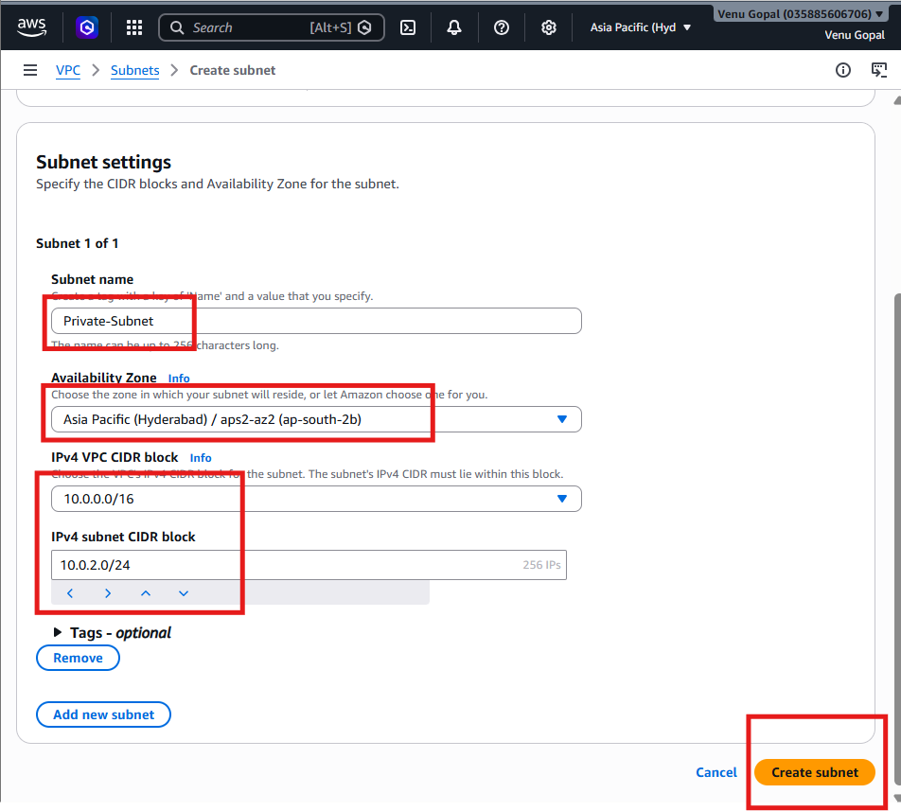

Step 6: Enable Auto-Assign Public IP for the Public Subnet
- Select Public-Subnet.
- Click Actions → Edit Subnet Settings.
- Enable:
✅ Auto-assign Public IPv4 Address
- Save.
Why?
Instances launched in the public subnet will automatically receive a public IP.
📸 Screenshot 5: Auto-assign Public IP enabled.
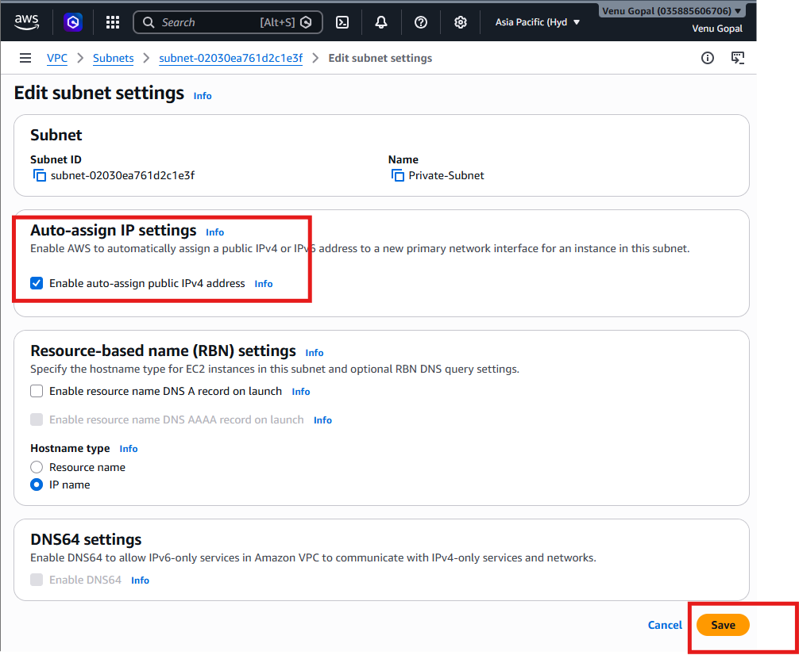

Step 7: Create an Internet Gateway
- Click Internet Gateways.
- Click Create Internet Gateway.
Enter:
Field | Value
Name | Advanced-IGW
Click Create Internet Gateway.
📸 Screenshot 6: Internet Gateway created.
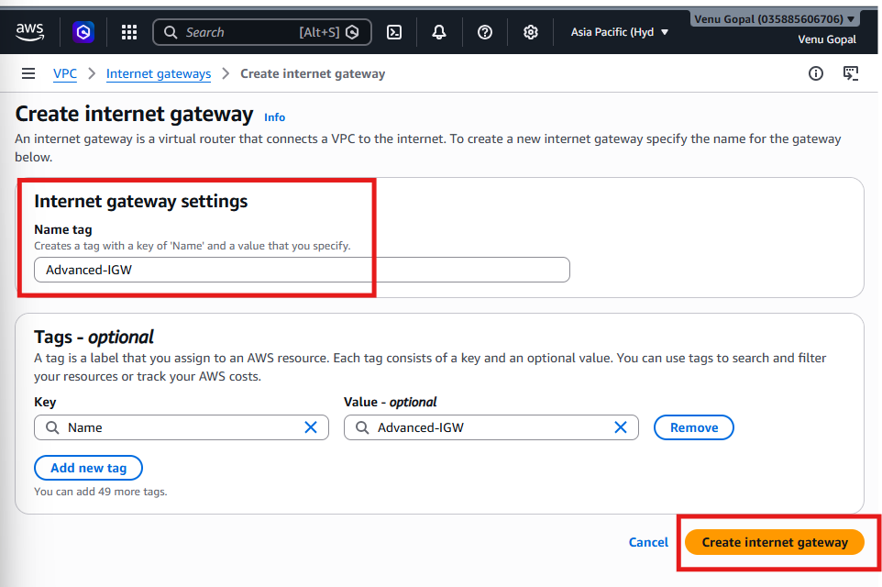

Step 8: Attach the Internet Gateway
- Select Advanced-IGW.
- Click Actions → Attach to VPC.
- Select Advanced-VPC.
- Click Attach Internet Gateway.
📸 Screenshot 7: Internet Gateway attached.
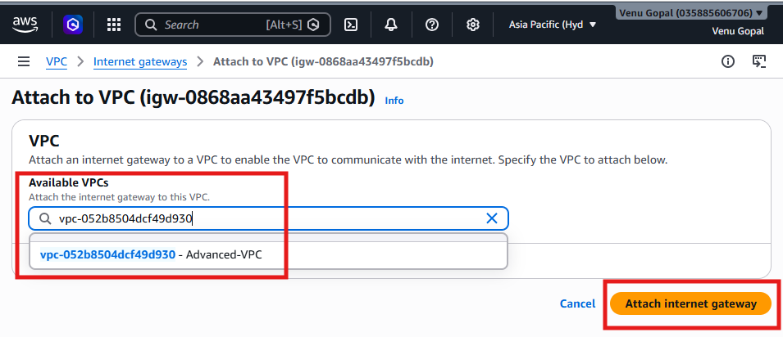

Step 9: Create the Public Route Table
- Click Route Tables.
- Click Create Route Table.
Enter:
Field | Value
Name | Public-RT
VPC | Advanced-VPC
Click Create Route Table.
📸 Screenshot 8: Public Route Table created.
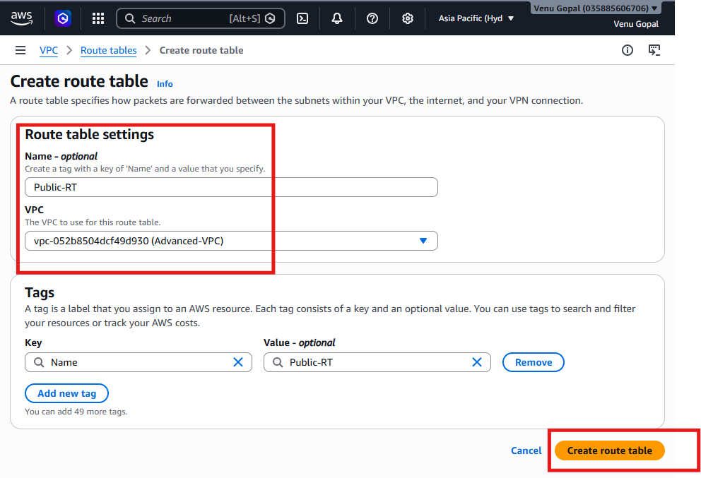

Step 10: Add Internet Route
- Open Public-RT.
- Select the Routes tab.
- Click Edit Routes → Add Route.
Destination | Target
0.0.0.0/0 | Internet Gateway → Advanced-IGW
Click Save Changes.
📸 Screenshot 9: Internet route added.
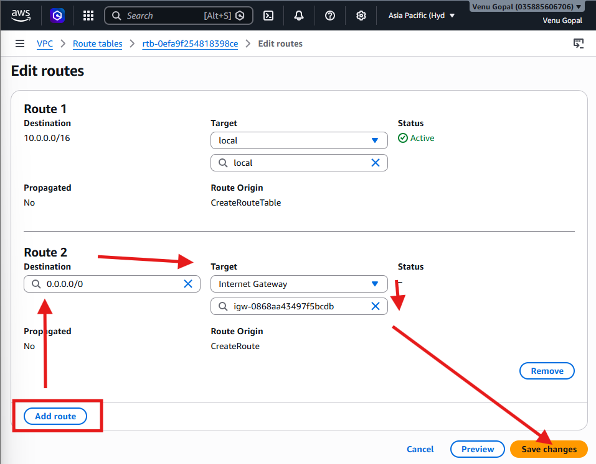

Step 11: Associate Public Subnet
- In Public-RT, go to Subnet Associations.
- Click Edit Subnet Associations.
- Select Public-Subnet.
- Save.
📸 Screenshot 10: Public subnet associated.
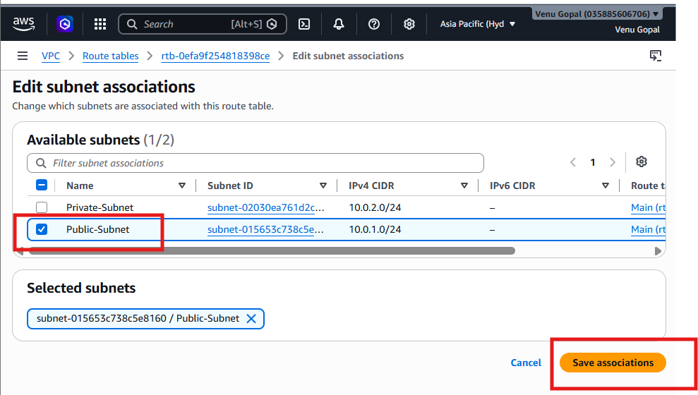

Step 12: Create the Private Route Table
- Click Create Route Table.
Enter:
Field | Value
Name | Private-RT
VPC | Advanced-VPC
Click Create Route Table.
📸 Screenshot 11: Private Route Table created.

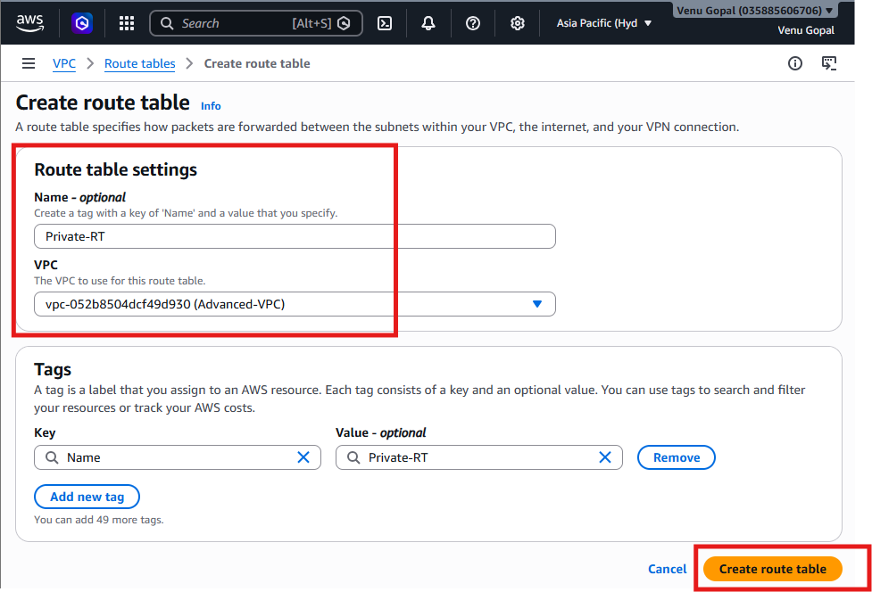
Step 13: Associate the Private Subnet
- Open Private-RT.
- Go to Subnet Associations.
- Click Edit Subnet Associations.
- Select Private-Subnet.
- Save.
📸 Screenshot 12: Private subnet associated.
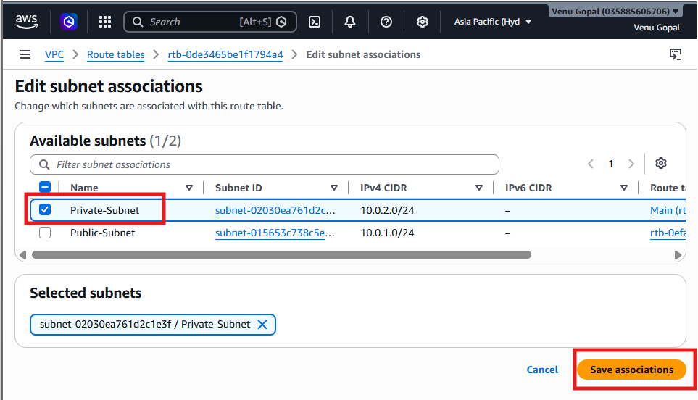
Final Validation
Verify your setup:
Resource | Name
VPC | Advanced-VPC
Public Subnet | Public-Subnet (10.0.1.0/24)
Private Subnet | Private-Subnet (10.0.2.0/24)
Internet Gateway | Advanced-IGW
Public Route Table | Public-RT
Private Route Table | Private-RT
Route Tables:
- Public-RT: Should have 10.0.0.0/16 (local) and 0.0.0.0/0 → Advanced-IGW.
- Private-RT: Should only have 10.0.0.0/16 (local) at this stage (no internet route yet).

Task 2: Enable Cross-Region VPC Peering
Objective
Create a VPC in a different AWS Region and establish a VPC Peering connection between the two VPCs so that resources can communicate using private IP addresses.

Architecture
AWS Region: ap-south-2 (Hyderabad)
-----------------------------------
VPC-1 (Advanced-VPC)
CIDR: 10.0.0.0/16
|
VPC Peering
|
AWS Region: ap-south-1 (Mumbai)
--------------------------------
VPC-2 (Mumbai-VPC)
CIDR: 20.0.0.0/16
Why use 20.0.0.0/16?
VPCs participating in peering must not have overlapping CIDR blocks. Since your Hyderabad VPC uses 10.0.0.0/16, we'll use 20.0.0.0/16 for the Mumbai VPC.

Step 1: Switch to Another Region
- In the AWS Console, click the Region selector (top-right).
- Change the region from Hyderabad (ap-south-2) to Mumbai (ap-south-1).
📸 Screenshot 1: Region switched to Mumbai.

Step 2: Create a New VPC in Mumbai
Go to VPC → Your VPCs → Create VPC
Fill in the details:
Field | Value
Resources to create | VPC only
Name | Mumbai-VPC
IPv4 CIDR | 20.0.0.0/16
Tenancy | Default
Click Create VPC.
📸 Screenshot 2: Mumbai-VPC created.
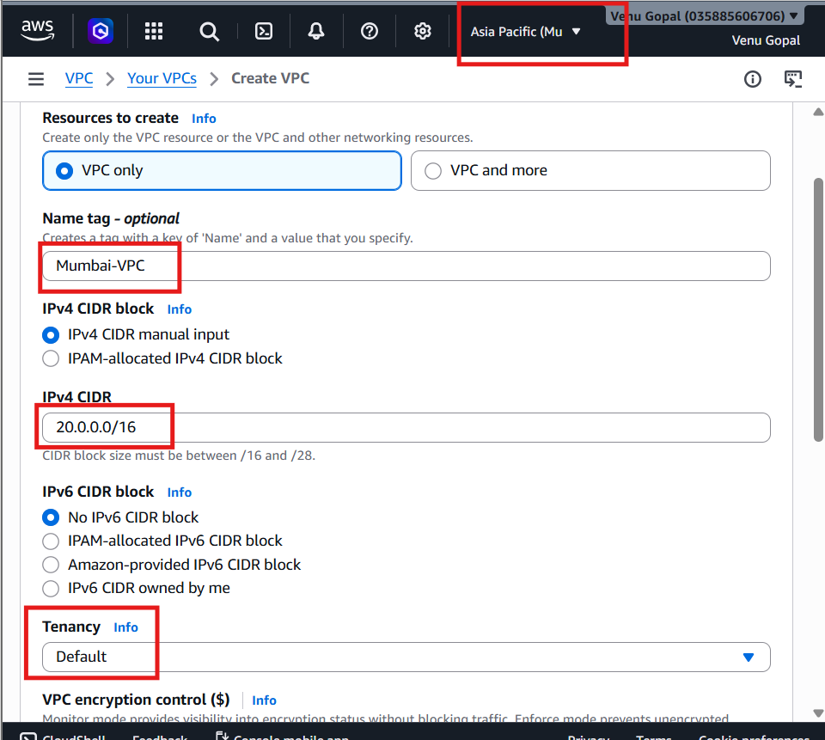
Step 3: Create a Public Subnet in Mumbai
Go to VPC → Subnets → Create Subnet
Field | Value
VPC | Mumbai-VPC
Name | Mumbai-Public-Subnet
Availability Zone | ap-south-1a (or another available AZ)
IPv4 CIDR | 20.0.1.0/24
Click Create Subnet.
📸 Screenshot 3: Mumbai Public Subnet created.
Note: For VPC peering, a subnet is enough. You don't need an Internet Gateway or EC2 yet unless you want to test connectivity later.
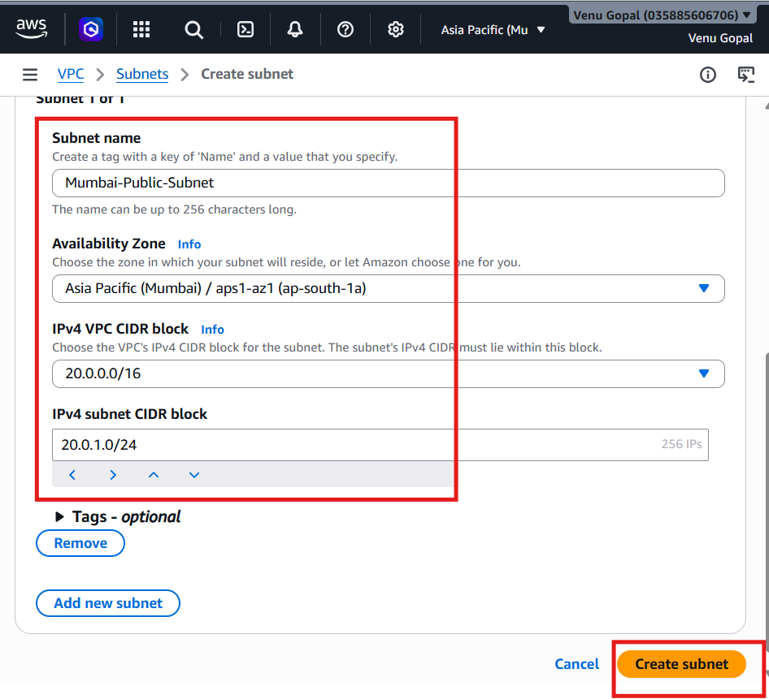

Step 4: Create the VPC Peering Connection
- Stay in the Mumbai region or switch back to Hyderabad (either side can initiate the request).
- Go to VPC → Peering Connections.
- Click Create Peering Connection.
Enter:
Field | Value
Name | Hyderabad-Mumbai-Peering
Requester VPC | Advanced-VPC (Hyderabad)
Account | My account
Region | Another Region
Region | Mumbai (ap-south-1)
Accepter VPC | Mumbai-VPC
Click Create Peering Connection.
📸 Screenshot 4: Peering request created (Pending Acceptance).
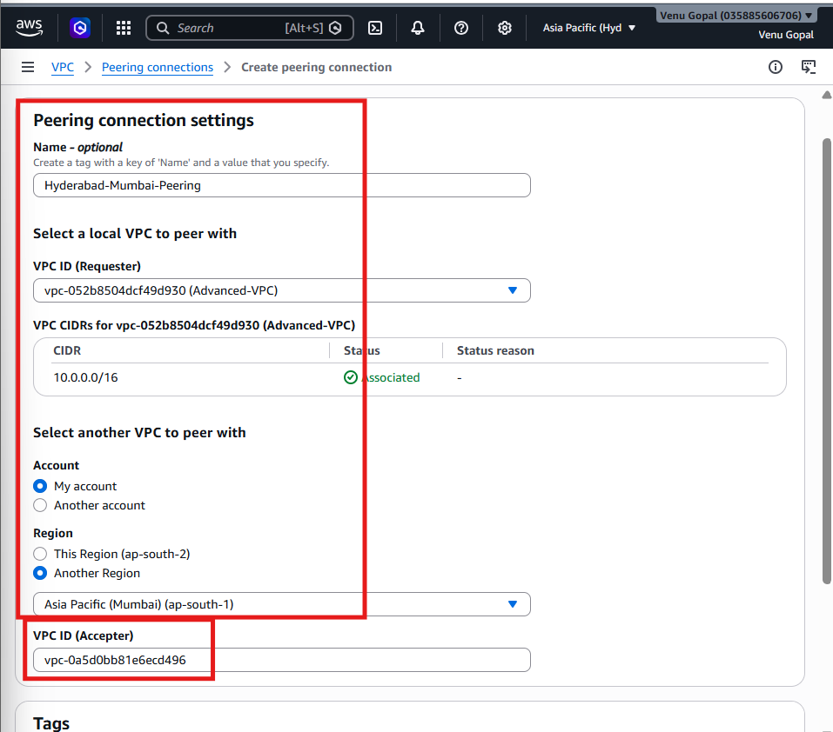

Step 5: Accept the Peering Request
If the Actions menu is still disabled:
- Click on the Peering Connection ID:
pcx-0573654f4737978c0
- This opens the details page.
- Look for an Accept Request button near the top or under Actions.
Next
- Switch to the Mumbai (ap-south-1) region.
- Go to VPC → Peering Connections.
- Select Hyderabad-Mumbai-Peering.
- Click Actions → Accept Request.
- Confirm the request.
Wait for a few seconds.
The status should change to:
Active
📸 Screenshot 1: Peering Connection status = Active
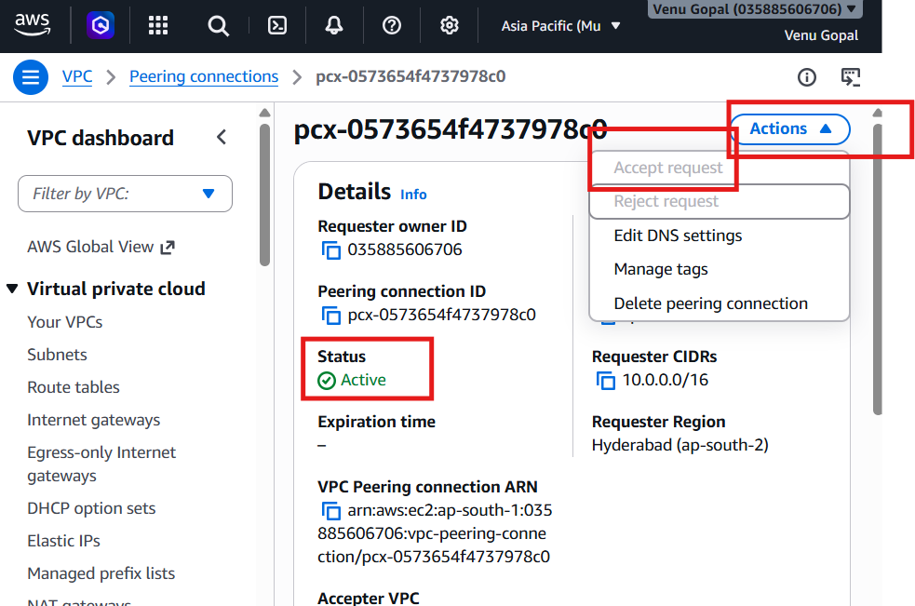

Step 6: Update the Hyderabad Route Table
Switch back to Hyderabad (ap-south-2).
Go to:
VPC → Route Tables
Open Public-RT.
Click:
Routes → Edit Routes → Add Route
Add:
Destination | Target
20.0.0.0/16 | Peering Connection (Select Hyderabad-Mumbai-Peering)
Click Save Changes.
If you have a Private-RT, repeat the same route there:
Destination | Target
20.0.0.0/16 | Peering Connection
📸 Screenshot 2: Hyderabad Route Table updated.
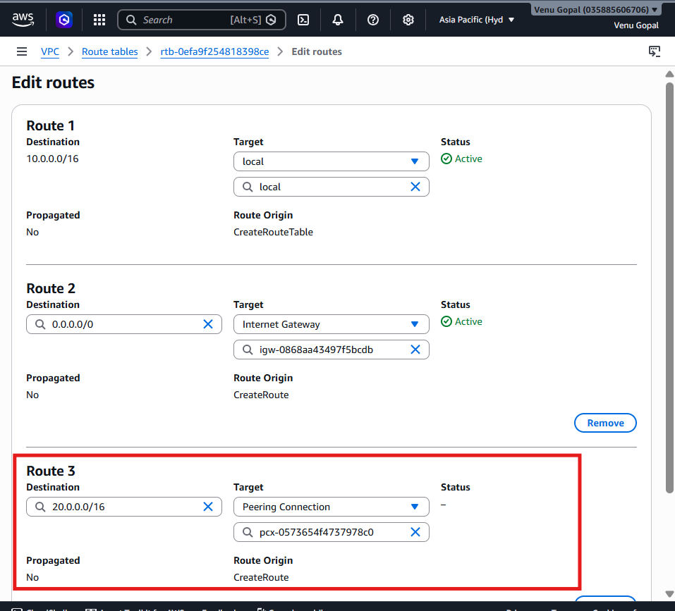

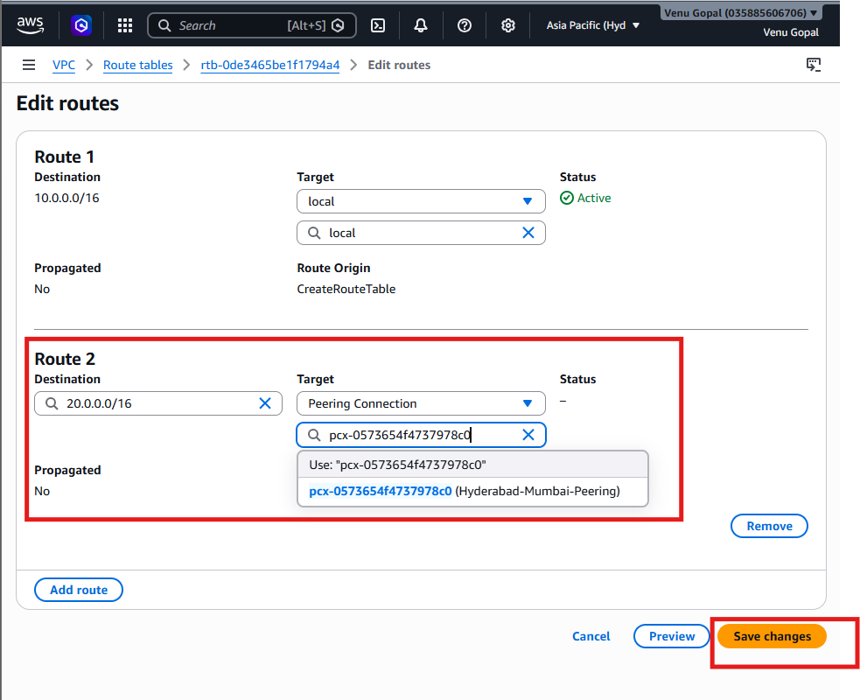

Step 7: Update the Mumbai Route Table
Switch to Mumbai (ap-south-1).
Go to:
VPC → Route Tables
Open the route table associated with Mumbai-Public-Subnet.
Click:
Routes → Edit Routes → Add Route
Add:
Destination | Target
10.0.0.0/16 | Peering Connection (Hyderabad-Mumbai-Peering)
Click Save Changes.
📸 Screenshot 3: Mumbai Route Table updated.
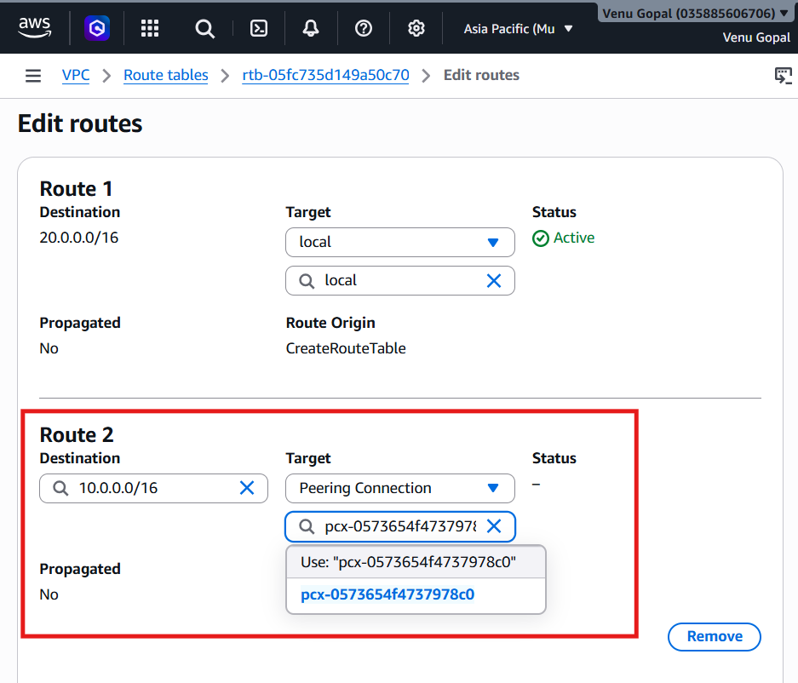

Step 8: Verify the Peering Connection
Go to:
VPC → Peering Connections
Verify:
Property | Expected Value
Status | Active
Requester VPC | Advanced-VPC
Accepter VPC | Mumbai-VPC
Requester Region | Hyderabad (ap-south-2)
Accepter Region | Mumbai (ap-south-1)
📸 Screenshot 4: Active Peering Connection.
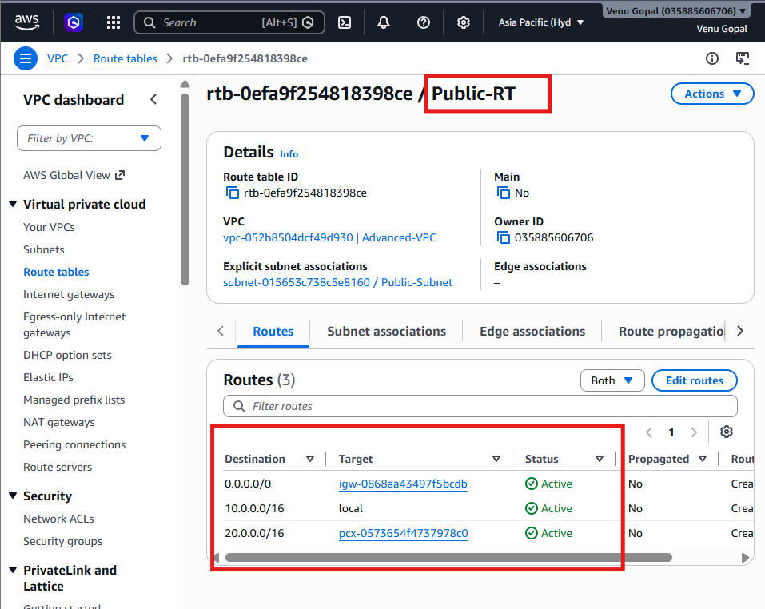
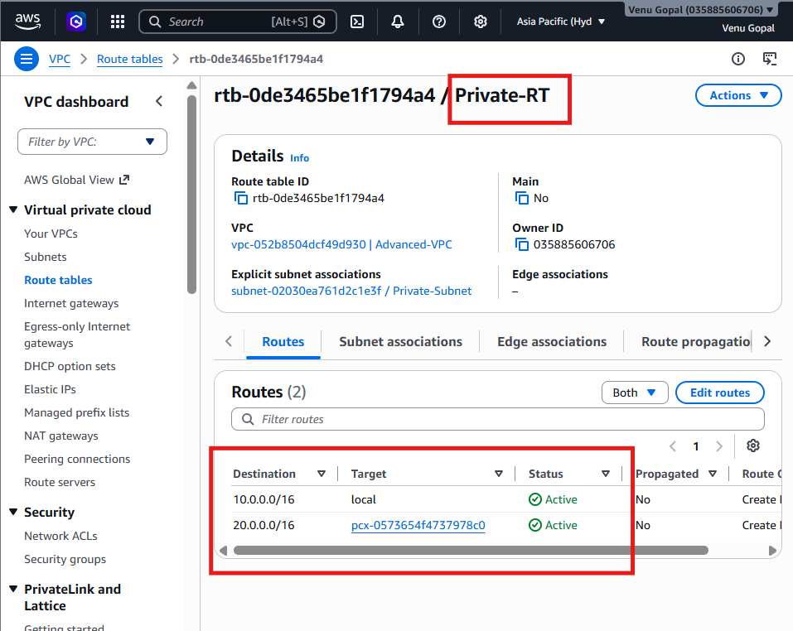

Validation
Your cross-region VPC peering is correctly configured when:
- ✅ Peering connection status is Active.
- ✅ Hyderabad route table has a route to 20.0.0.0/16 via the peering connection.
- ✅ Mumbai route table has a route to 10.0.0.0/16 via the peering connection.
Optional connectivity test: Launch one EC2 instance in each VPC, update their security groups to allow ICMP (or the required ports) from the opposite VPC's CIDR, and verify that they can communicate using their private IP addresses.

Task 3: Enable Cross-Account VPC Peering
Objective
Create a VPC peering connection between two different AWS accounts.
Architecture
AWS Account A (Your Account)
----------------------------
Advanced-VPC
CIDR: 10.0.0.0/16
|
VPC Peering
|
AWS Account B (Friend's Account)
-------------------------------
Friend-VPC
CIDR: 30.0.0.0/16

Prerequisites
You need:
- Your AWS Account (Account A)
- A friend's AWS Account (Account B)
Your friend should create:
Resource | Value
VPC Name | Friend-VPC
CIDR | 30.0.0.0/16
Then ask your friend to share:
- AWS Account ID
- VPC ID
- Region

Step 1: Create Peering Connection
Go to:
VPC → Peering Connections → Create Peering Connection
Enter:
Field | Value
Name | Cross-Account-Peering
Requester VPC | Advanced-VPC
Account | Another account
Accepter AWS Account ID | Your friend's AWS Account ID
Region | Region where your friend's VPC exists
Accepter VPC ID | Your friend's VPC ID
Click Create Peering Connection.
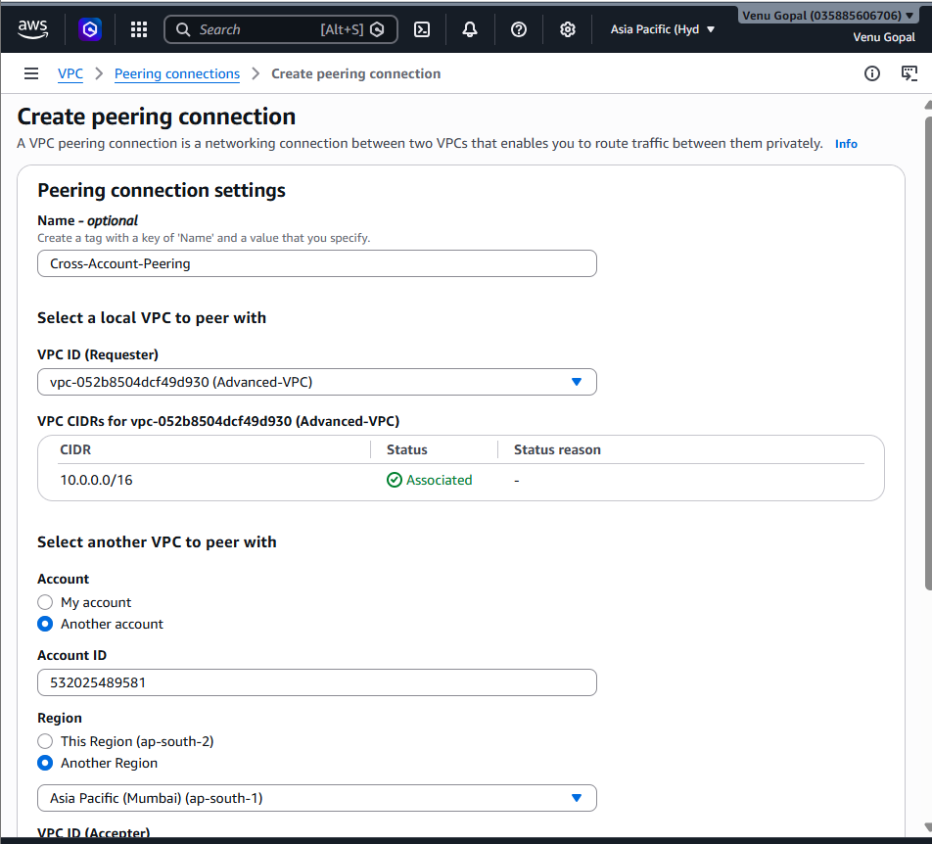
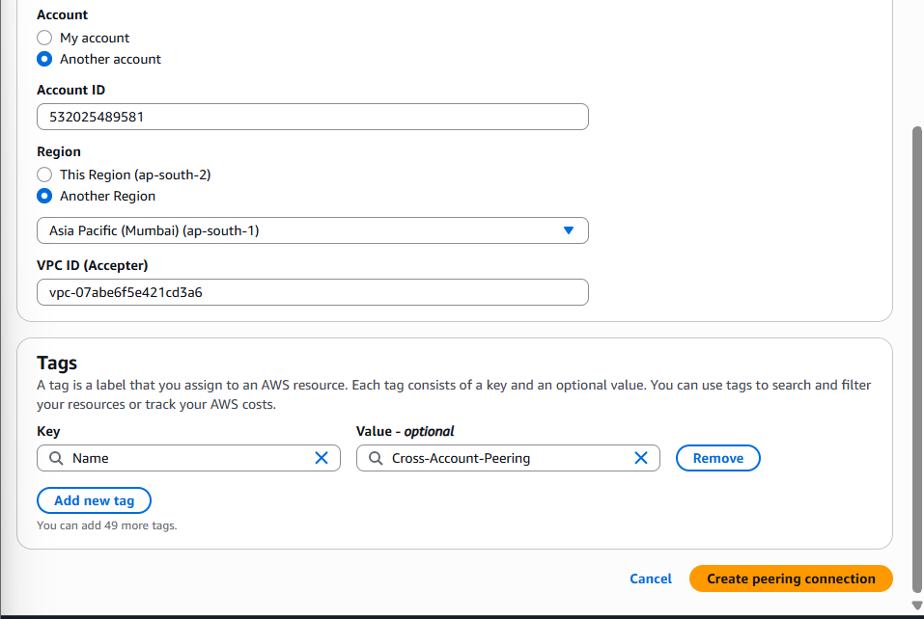

Step 2: Friend Accepts the Request
Your friend logs into their AWS account.
Go to:
VPC → Peering Connections
Select the pending request.
Click:
Actions → Accept Request
Status becomes:
Active
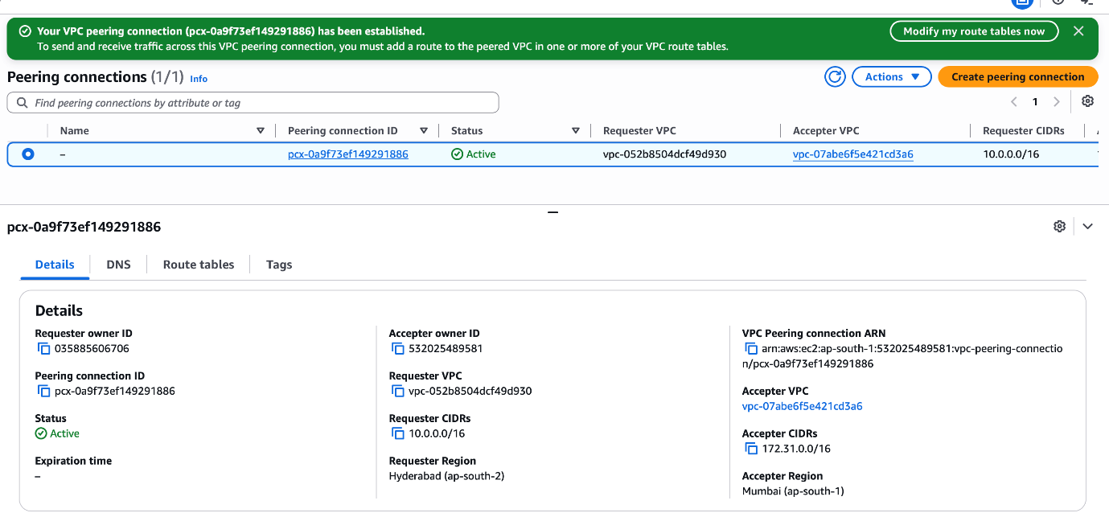

Step 3: Update Route Tables
Your Route Table
Add:
Destination | Target
30.0.0.0/16 | Cross-Account Peering Connection
Friend's Route Table
Add:
Destination | Target
10.0.0.0/16 | Cross-Account Peering Connection
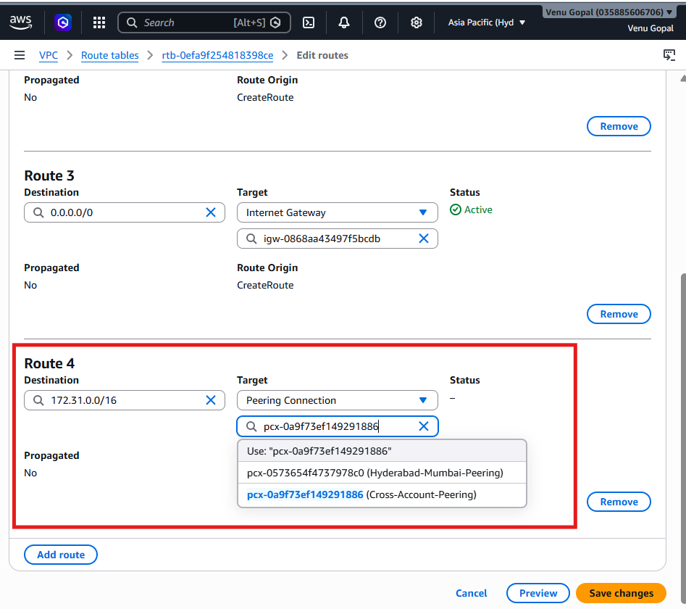

Step 4: Security Groups
Allow the required traffic (for example, ICMP for ping or SSH) from the other VPC's CIDR.

Validation
Launch an EC2 instance in each VPC and verify connectivity using private IP addresses.
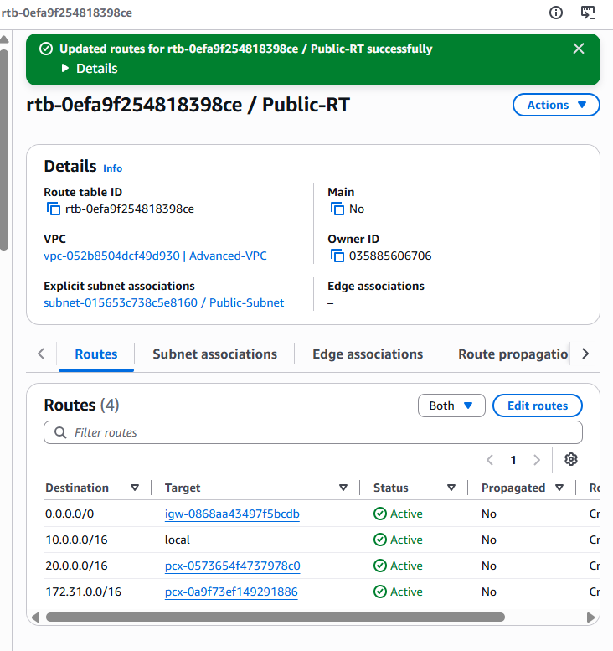

Mine Private-RT Configuration:
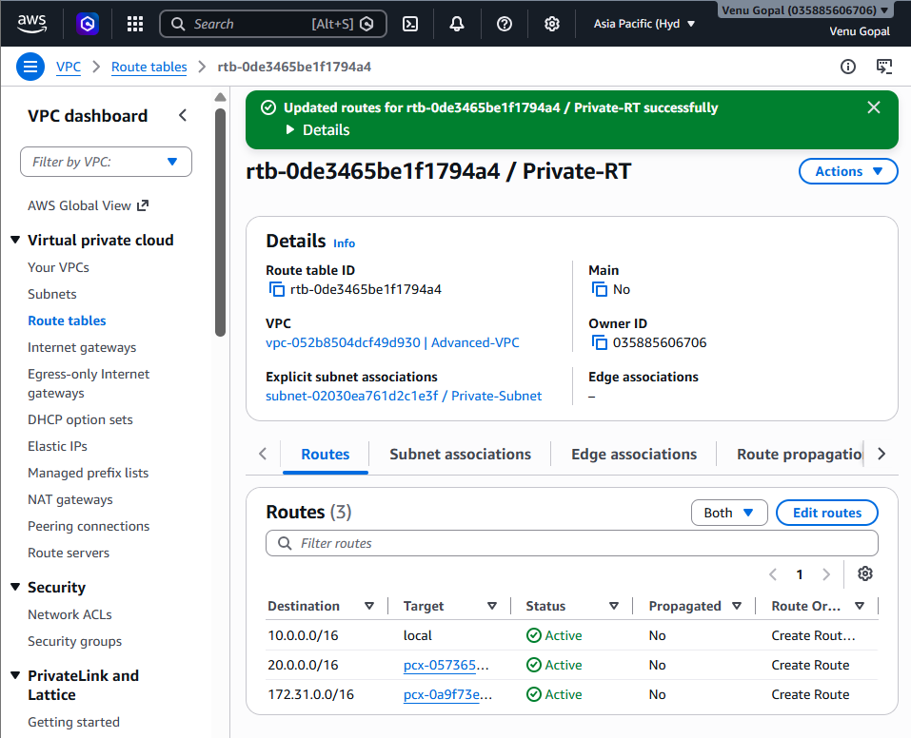

My Friend’s Configuration:
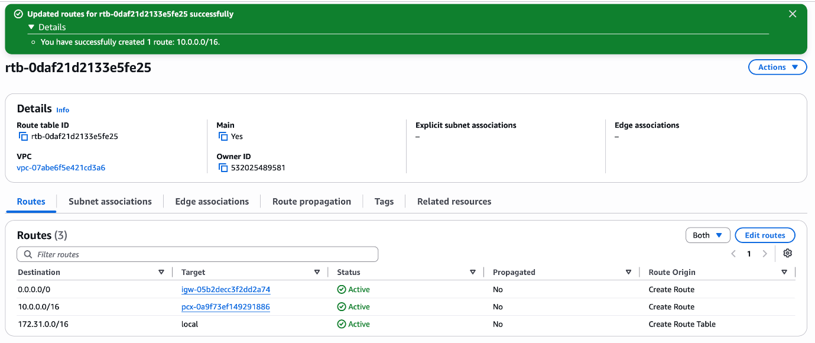

Why does my friend need to update their route table?
Yes, if you want actual communication between the two VPCs.
Here's why:
Without your friend's route
Your EC2 -----> Friend's EC2
✅ Request reaches friend

Friend's EC2 -----> Your EC2
❌ Doesn't know how to return
Your packet reaches your friend's VPC, but the response has no route back.

With both route tables updated
Your EC2 <------> Friend's EC2
✅ Two-way communication
This is the correct AWS networking configuration.

Task 4: Set Up a Transit Gateway:
Objective
Create a Transit Gateway (TGW) and attach your VPCs to it.
What is a Transit Gateway?
A Transit Gateway acts like a central router (hub) for multiple VPCs.
Without Transit Gateway
VPC-A <------> VPC-B
\ /
\ /
VPC-C
If you have 3 VPCs, you need multiple peering connections.

With Transit Gateway
Transit Gateway
/ | \
/ | \
VPC-A VPC-B VPC-C
Each VPC connects only to the Transit Gateway, making the network easier to manage.

Step 1: Create the Transit Gateway
- Switch to Hyderabad (ap-south-2).
- Go to VPC.
- In the left menu, click Transit Gateways.
- Click Create Transit Gateway.
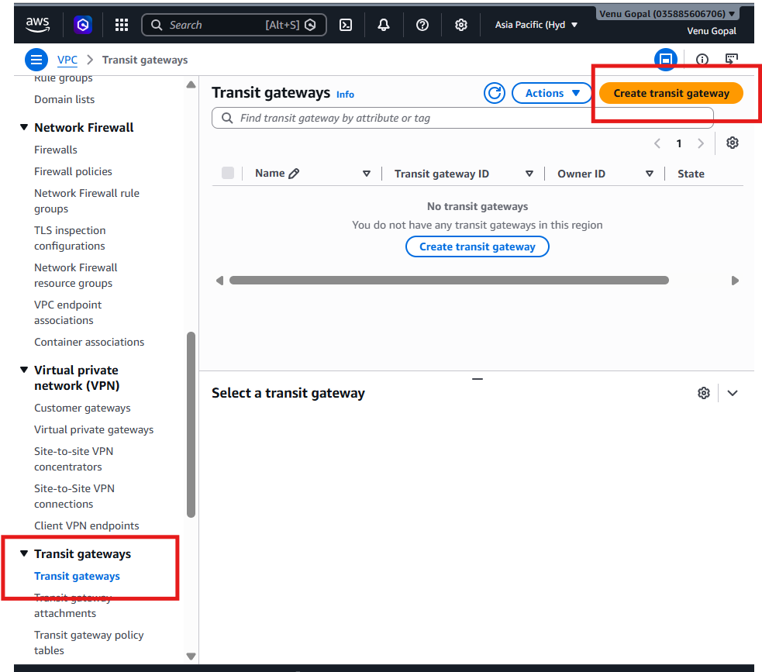
Enter:
Field | Value
Name tag | Advanced-TGW
Description | Transit Gateway for VPC Connectivity
Amazon side ASN | Leave the default (64512)
All other settings | Leave as default
Click Create Transit Gateway.
What is ASN?
ASN (Autonomous System Number) is used by BGP (Border Gateway Protocol), mainly when connecting Transit Gateways to VPNs or Direct Connect. For your VPC-to-VPC lab, the default private ASN 64512 is perfectly fine.
Fill it like this:
Amazon side ASN: 64512

DNS Support: Enable

Security Group Referencing Support: Disable

VPN ECMP Support: Enable

Default Route Table Association: Enable

Default Route Table Propagation: Enable

Multicast Support: Disable

📸 Screenshot 1: Transit Gateway created.
Wait until the State becomes Available.
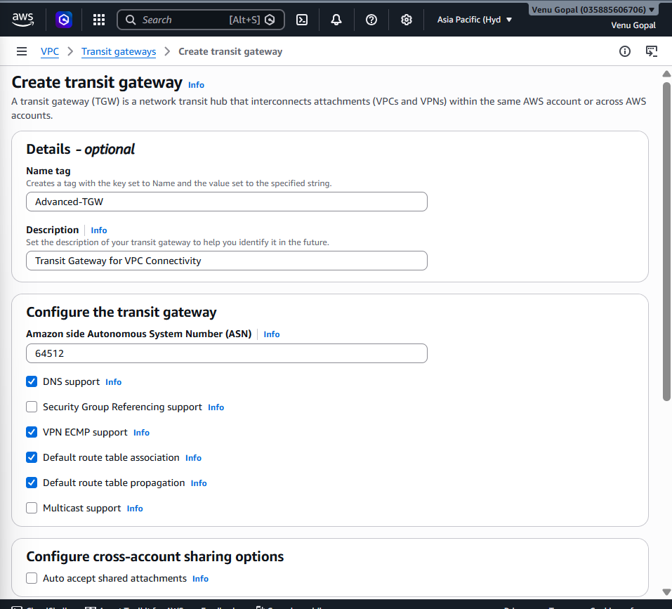

Step 2: Create a Transit Gateway Attachment for Hyderabad VPC
- In the left menu, click Transit Gateway Attachments.
- Click Create Transit Gateway Attachment.
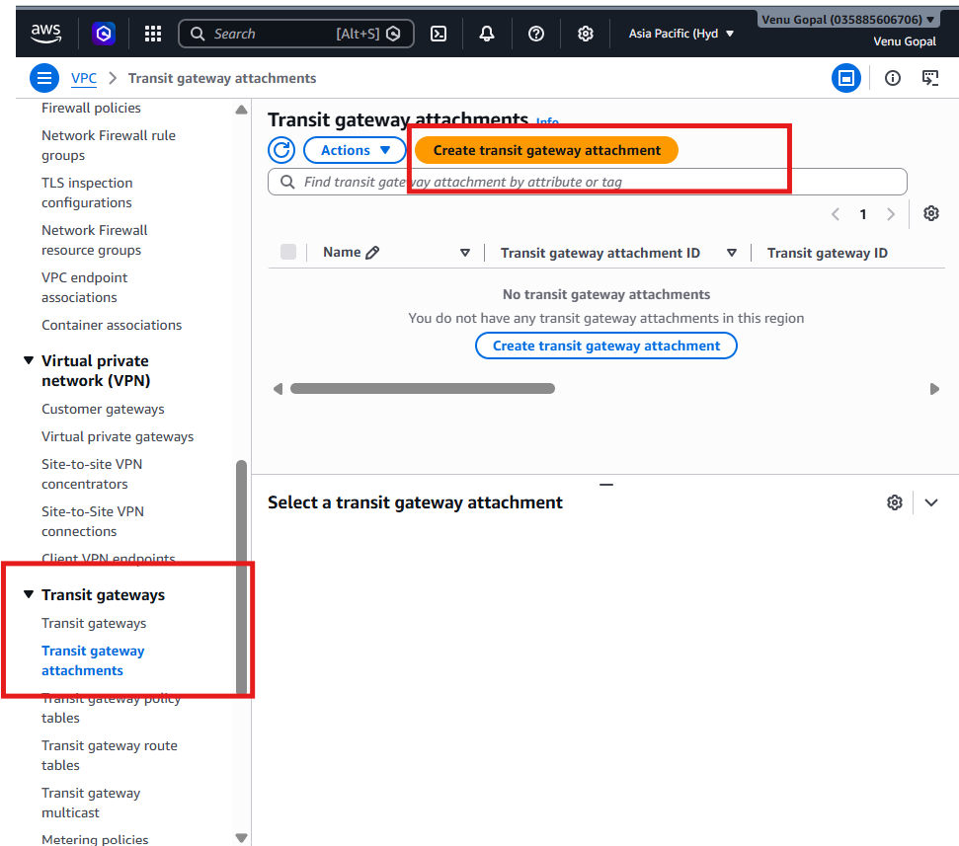
Enter:
Field | Value
Transit Gateway ID | Advanced-TGW
Attachment Type | VPC
VPC | Advanced-VPC
Subnet | Select one subnet (for example, Public-Subnet)
Note: AWS requires you to select one subnet per Availability Zone that the Transit Gateway will use. Since you currently have one public and one private subnet in different AZs, you can select one subnet in each AZ if available. For this lab, selecting the available subnet(s) is sufficient.
Click Create Attachment.
📸 Screenshot 2: Hyderabad VPC attached.
Wait until the attachment status becomes Available.

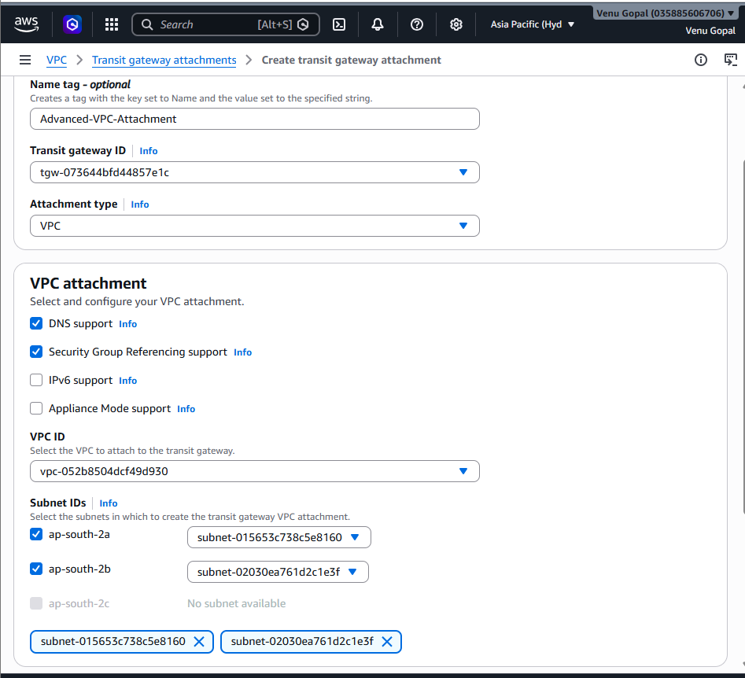

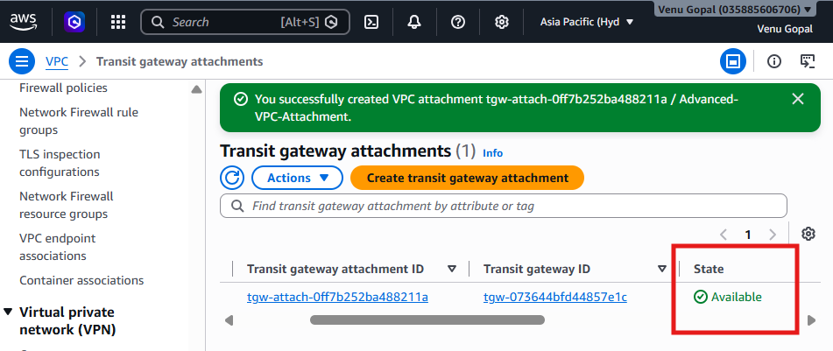
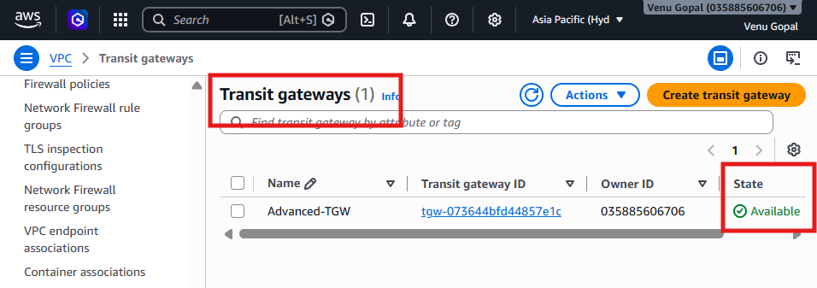

Step 3: Verify the Transit Gateway
Go to:
VPC → Transit Gateways
Open Advanced-TGW.
Verify:
Property | Expected
State | Available
Attachments | 1
Default Association | Enabled
Default Propagation | Enabled
📸 Screenshot 3: Transit Gateway details.
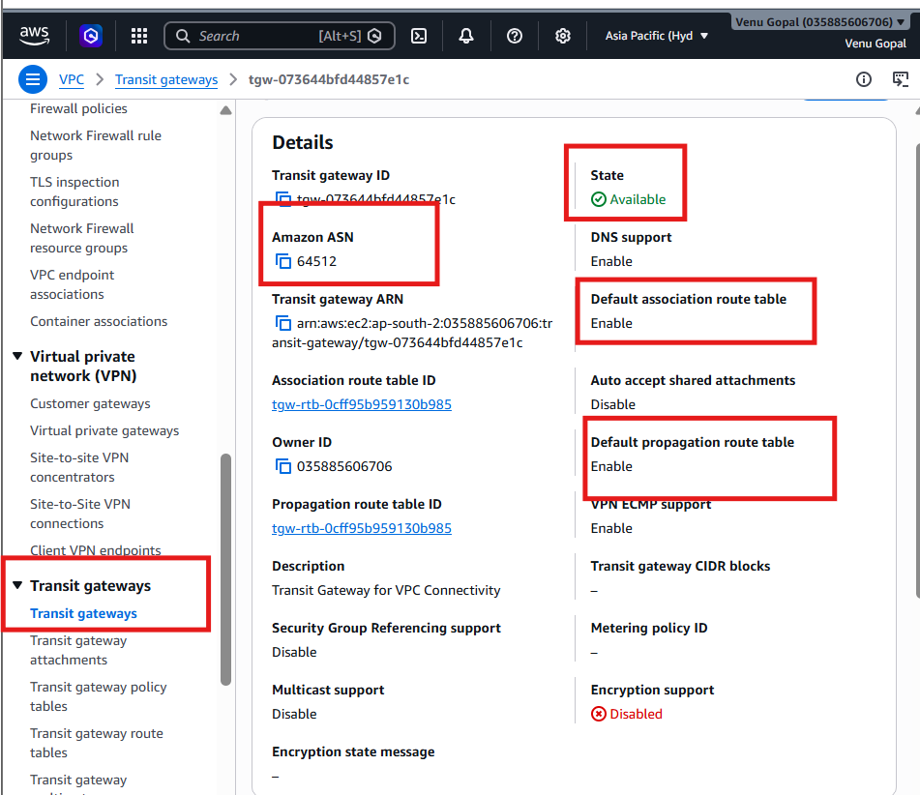

Step 4: Verify the Transit Gateway Route Table
Go to:
VPC → Transit Gateway Route Tables
You should see a default route table.
Open it and check:
Associations Tab
You should see:
- ✅ Advanced-VPC-Attachment
Propagations Tab
You should see:
- ✅ Advanced-VPC-Attachment
📸 Screenshot 4: Route Table Associations.
📸 Screenshot 5: Route Table Propagations.
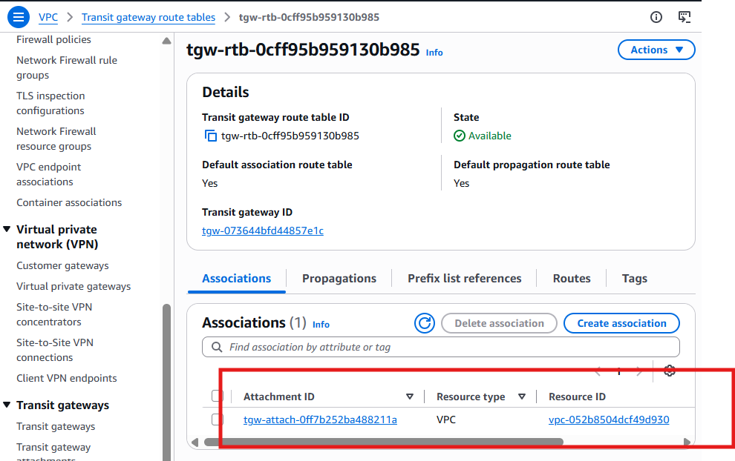
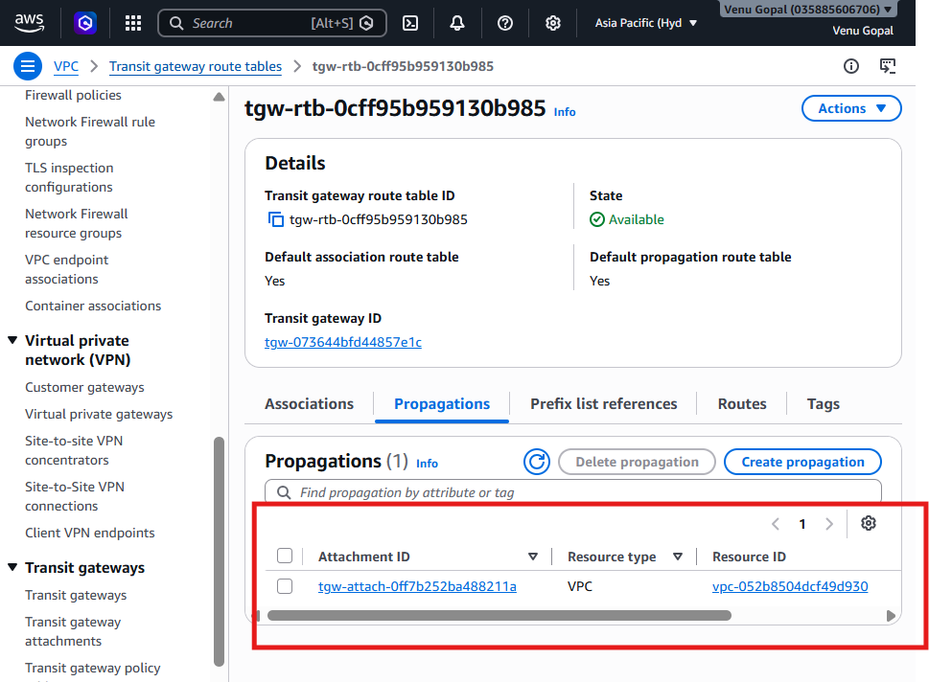

Step 5: Do You Need to Add Routes?
With only one attached VPC
No.
Since only Advanced-VPC is attached to the Transit Gateway, there is no second VPC to route traffic to.
You do not need to edit your VPC route tables at this point.

Step 6 (Only if You Have a Second Hyderabad VPC)
If later you create another VPC in Hyderabad (for example, 10.1.0.0/16):
- Create a Transit Gateway attachment for that VPC.
- Update route tables:
Advanced-VPC Route Table
Destination | Target
10.1.0.0/16 | Transit Gateway (tgw-...)
Second VPC Route Table
Destination | Target
10.0.0.0/16 | Transit Gateway (tgw-...)
This enables communication between the two VPCs through the Transit Gateway.

Task 5: Set Up a VPC Endpoint
Objective
Create a Gateway VPC Endpoint for Amazon S3 so that resources in your VPC can access S3 without going through the Internet Gateway or NAT Gateway.

Architecture
Advanced-VPC
10.0.0.0/16
-----------------------
| |
Public Subnet Private Subnet
| |
-----------------------
|
S3 Gateway Endpoint
|
Amazon S3

Step 1: Open VPC Endpoints
- Login to AWS Console.
- Stay in Hyderabad (ap-south-2).
- Go to VPC.
- In the left menu, click Endpoints.
- Click Create endpoint.

Step 2: Basic Configuration
Fill in:
Field | Value
Name tag | S3-VPC-Endpoint
Service category | AWS services
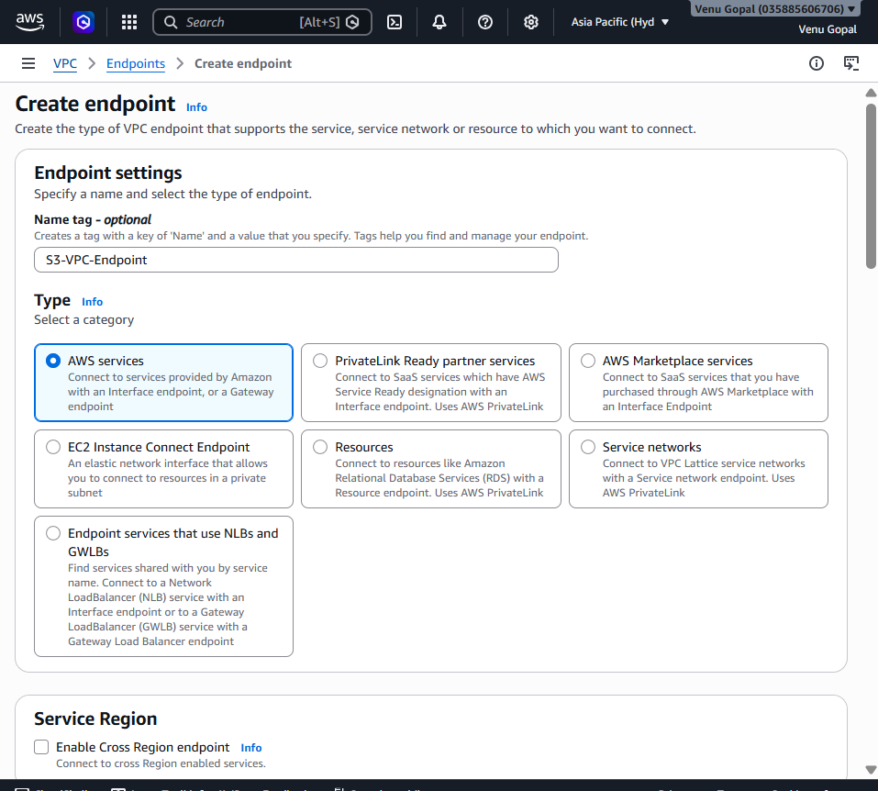

Step 3: Select the Service
In Services, search for S3.
Select the service similar to:
com.amazonaws.ap-south-2.s3
Important: Select the service whose Type is Gateway.
It should look similar to:
Service Name | Type
com.amazonaws.ap-south-2.s3 | Gateway ✅
❌ Do not select an Interface endpoint.

Step 4: Select the VPC
Choose:
Field | Value
VPC | Advanced-VPC
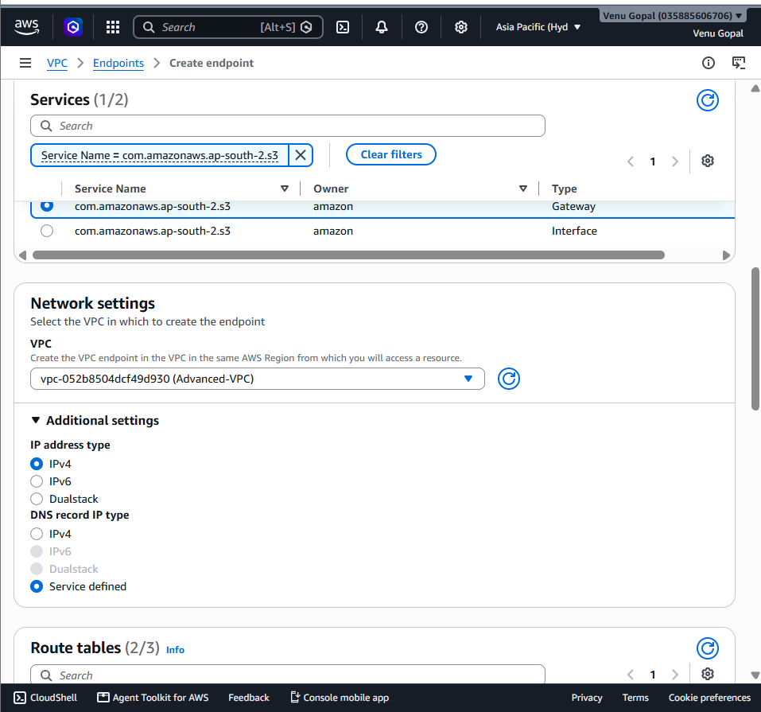

Step 5: Configure Route Tables
AWS will display your route tables.
Select:
- ✅ Public-RT
- ✅ Private-RT
Example:
☑ Public-RT
☑ Private-RT
This automatically adds the required S3 endpoint routes to those route tables.

Step 6: Policy
Choose:
Full Access
(Default option)
You don't need to create a custom policy for this lab.
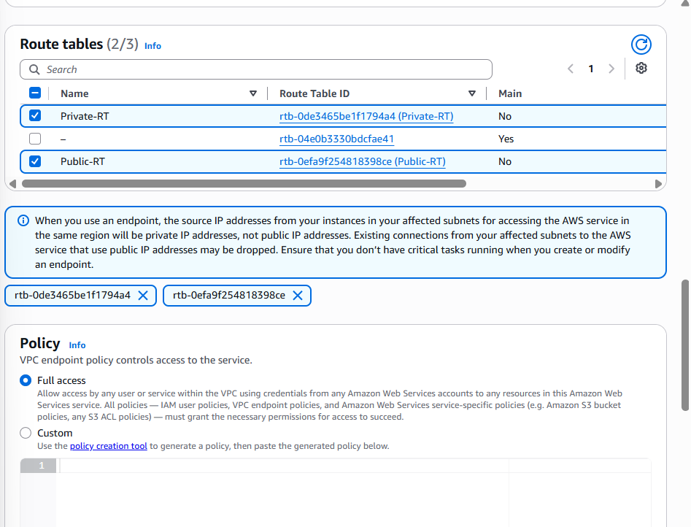
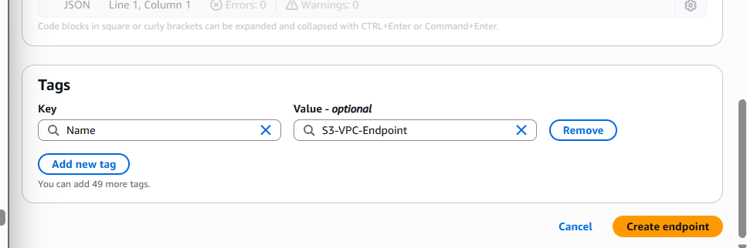

Step 7: Create the Endpoint
Click:
Create endpoint
Wait for the status to become:
Available
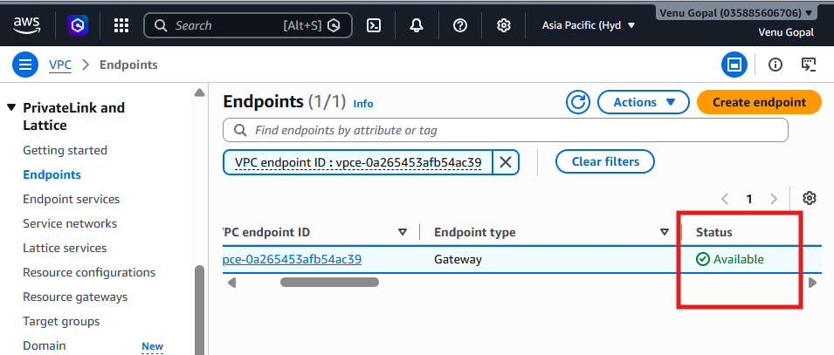

Step 8: Verify
Go to:
VPC → Endpoints
Verify:
Property | Expected
State | Available
Type | Gateway
Service | S3
VPC | Advanced-VPC
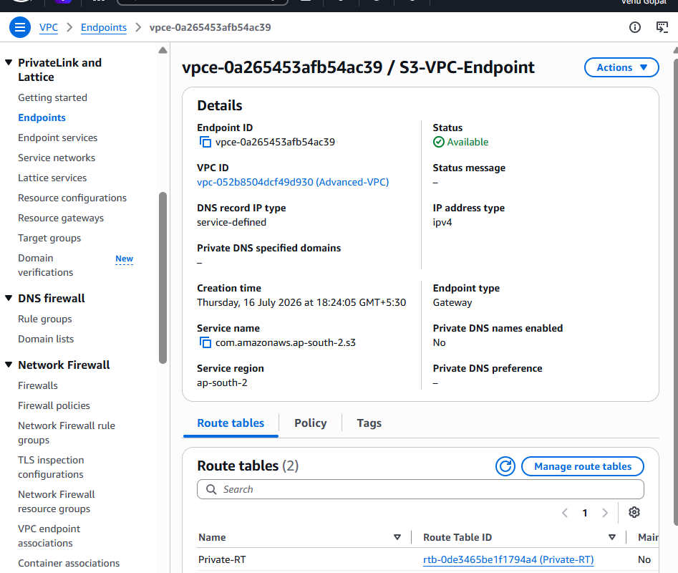

Step 9: Verify Route Tables
Open:
- Public-RT
- Private-RT
You should now see an automatically added route similar to:
Destination | Target
S3 Prefix List (pl-...) | vpce-...
This route is added by AWS when you associate the route tables with the S3 Gateway Endpoint.
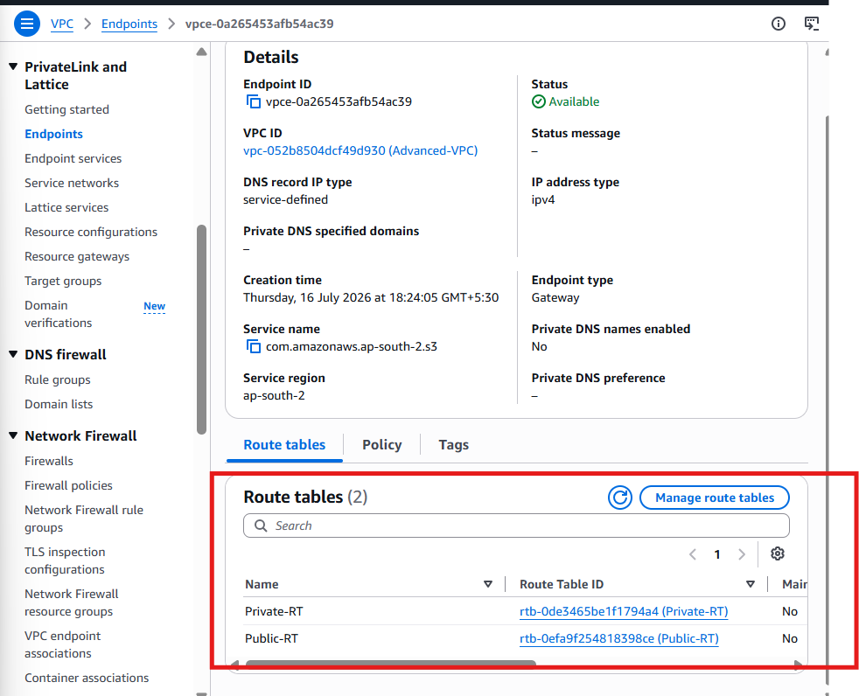

Optional Test
If you have an EC2 instance with an IAM role that has S3 permissions, you can verify the endpoint by running:
aws s3 ls
The traffic will stay within the AWS network instead of using the Internet Gateway.

